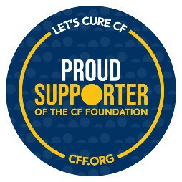

Dear Community Supporter,

I am a volunteer who is organizing a community event to support the mission of the Cystic Fibrosis Foundation, a non-profit that is leading the way in the fight against cystic fibrosis. In people living with CF, a defective gene causes a thick buildup of mucus in the lungs, pancreas, and other organs which leads to infections, extensive lung damage, and respiratory failure.

Finding a cure for CF is something I am passionate about because I have seen first-hand the effects of this disease on someone who is close to me.

The event I am helping to plan is to support my loved one and all people living with cystic fibrosis. We are driven by a dream that one day – every person with cystic fibrosis will have the chance to live a long, healthy life. Working alongside the CF community, the Foundation continues to drive extraordinary results. The life expectancy of someone born with CF has doubled in the last 30 years, yet we still lose precious lives to CF every day. Our vision is a cure for every person with cystic fibrosis and a life free from the burden of this disease. We will not leave anyone behind. You have an opportunity to be a part of ending this disease.

On behalf of all those living with CF and the CF Foundation, we thank you in advance for your consideration to contribute to this community event and your willingness to make a difference.

If you’d like to help support our mission, please complete and return the attached donation form. If you have any questions or require any further information, please feel free to contact me using the information I provided below.

Until there’s a cure,

INSERT HERE: NAME

INSERT HERE: CONTACT INFO 1 INSERT HERE: CONTACT INFO 2



# ITEM INFORMATION:EVENT NAME:

**AUCTION PROCUREMENT FORM**

# EVENT DATE:

# EVENT LOCATION:

ITEM:

VALUE: (If actual value is unknown, please estimate)

DESCRIPTION:

RESTRICTIONS:

# DONOR INFORMATION

NAME:

COMPANY:

ADDRESS:

PHONE:

EMAIL:

MAILED DELIVERED

**ITEM OR CERTIFICATE WILL BE:**

CALL FOR PICK UP

PLEASE MAKE A

CERTIFICATE FOR ME

# Please return this form by mail or email to:

Name________________________________

MAILING ADDRESS EMAIL

SOLICITED BY: DATE:

***\*Your in-kind support to this community event is not a direct contribution to the CF Foundation and is not considered tax-deductible.***